**AI Image Captioning**

**Introduction**

AI Image Captioning is a cutting-edge technology that combines computer vision and natural language processing to generate textual descriptions of images. This process involves analyzing an image's content and generating a meaningful caption that accurately describes the objects, actions, and context present in the image. The primary applications of AI image captioning include accessibility tools for the visually impaired, content automation, and image indexing for search engines.

**Module Description**

The AI image captioning system is divided into multiple modules:

1. **Image Preprocessing**: Converts input images into a format suitable for deep learning models, including resizing and normalization.
2. **Feature Extraction**: Utilizes a Convolutional Neural Network (CNN) like ResNet or Inception to extract high-level features from images.
3. **Sequence Modeling**: A Recurrent Neural Network (RNN) or Transformer model processes extracted features to generate captions.
4. **Decoder with Attention Mechanism**: Uses an attention mechanism to focus on important regions of the image while generating captions.
5. **Post-Processing and Output**: Converts generated token sequences into human-readable text.

**Workflow Diagrams**

**1. Overall Workflow Diagram**

[Input Image] --> [Preprocessing] --> [Feature Extraction (CNN)] --> [Caption Generation (RNN/Transformer)] --> [Output Text]

**2. Detailed Workflow for Caption Generation**

[Extracted Features] --> [Attention Mechanism] --> [RNN/Transformer Decoder] --> [Word Prediction] --> [Caption Generation]

**Workflow Descriptions**

1. **Input Image Acquisition**: The system receives an image from a user, which is preprocessed for uniformity.
2. **Feature Extraction**: A pre-trained CNN extracts relevant features from the image.
3. **Sequence Processing**: The extracted features are passed through an RNN/Transformer model, which sequentially predicts words.
4. **Attention Mechanism**: The system dynamically focuses on different parts of the image to improve caption quality.
5. **Caption Output**: The generated sequence of words is converted into a meaningful caption and displayed to the user.

**Coding**

<!DOCTYPE html>

<html lang="en">

<head>

    <meta charset="UTF-8">

    <meta name="viewport" content="width=device-width, initial-scale=1.0">

    <title>AI Image Captioning</title>

    <script defer src="https://cdn.jsdelivr.net/npm/@tensorflow/tfjs"></script>

    <script defer src="https://cdn.jsdelivr.net/npm/@tensorflow-models/mobilenet"></script>

    <script defer src="https://cdn.jsdelivr.net/npm/@tensorflow-models/handpose"></script>

    <style>

        body {

            font-family: Arial, sans-serif;

            text-align: center;

            background-color: #f4f4f4;

            margin: 20px;

        }

        #imagePreview {

            max-width: 100%;

            height: auto;

            margin-top: 20px;

            border: 2px solid black;

            border-radius: 10px;

        }

        #caption {

            margin-top: 10px;

            font-size: 18px;

            font-weight: bold;

        }

    </style>

</head>

<body>

    <h2>AI Image Captioning</h2>

    <input type="file" id="imageUpload" accept="image/*">

    <br>

    <img id="imagePreview" src="" alt="Image Preview" style="display: none;">

    <p id="caption"></p>

    <script>

        const imageUpload = document.getElementById("imageUpload");

        const imagePreview = document.getElementById("imagePreview");

        const caption = document.getElementById("caption");

        async function loadModel() {

            return await mobilenet.load();

        }

        async function generateCaption(image) {

            const model = await loadModel();

            const predictions = await model.classify(image);

            return `This looks like ${predictions[0].className} with a confidence of ${Math.round(predictions[0].probability * 100)}%`;

        }

        imageUpload.addEventListener("change", async (event) => {

            const file = event.target.files[0];

            if (file) {

                const reader = new FileReader();

                reader.onload = async function(e) {

                    imagePreview.src = e.target.result;

                    imagePreview.style.display = "block";

                    caption.innerText = "Analyzing...";

                    setTimeout(async () => {

                        caption.innerText = await generateCaption(imagePreview);

                    }, 1000);

                };

                reader.readAsDataURL(file);

            }

        });

    </script>

</body>

</html>

**Screenshots**

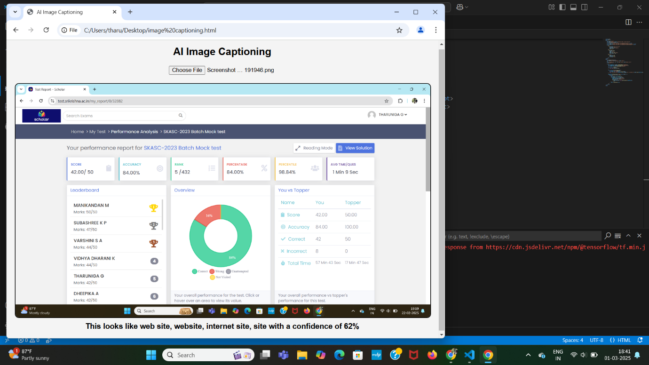

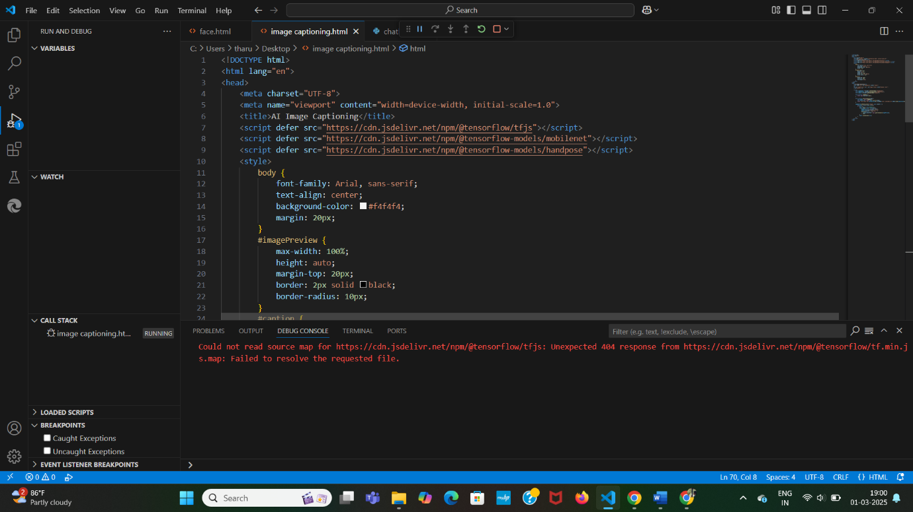

**Conclusion**

AI Image Captioning is a powerful tool with broad applications in accessibility, content management, and search enhancement. The integration of CNNs for feature extraction and RNNs/Transformers for text generation makes it an effective approach. Future improvements may include better contextual understanding, multilingual captioning, and real-time processing for enhanced user experience.